SATAYA 2026 REGISTRATION FORM
To be completed and signed, then sent to:
Michaël Benoit
compagnieartichaut777@gmail.com - +33 6 80 43 99 79

SESSION FROM June 28 to July 5 2026
First Name (as on your passport):
Last Name (as on your passport):
Passport Number:
Passport Validity:
Nationality:
Email:
Date of Birth:
Phone (GSM):
Current Address (Street + Number):
City:
Postal Code:

SIGNATURE
I confirm my reservation for the Sataya session:
- From June 28 to July 5

And I commit to paying:
- A deposit of €500 within 5 business days to confirm my booking
- The balance of the session (1000€) no later than 2 months before the start of the stay.
- And i confirm that i will take my flight ticket from my home place to Marsa Alam airport or Hurghada at the dates and hours that would be communicated by the organizers to be ready for the bus transfer to Sataya.
Payment should be made to the following IBAN account:
IBAN: FR76 3000 3004 4100 0372 8190 080
BIC: SOGEFRPP
Name: Artichaut
Address: 59 Route de Cugand, 44190 Clisson, France
With the note: First Name & Last Name – Sataya session – session dates – deposit or balance
I also declare that I have read and accepted the travel conditions.
Date:
Signature preceded by "Read & Approved":

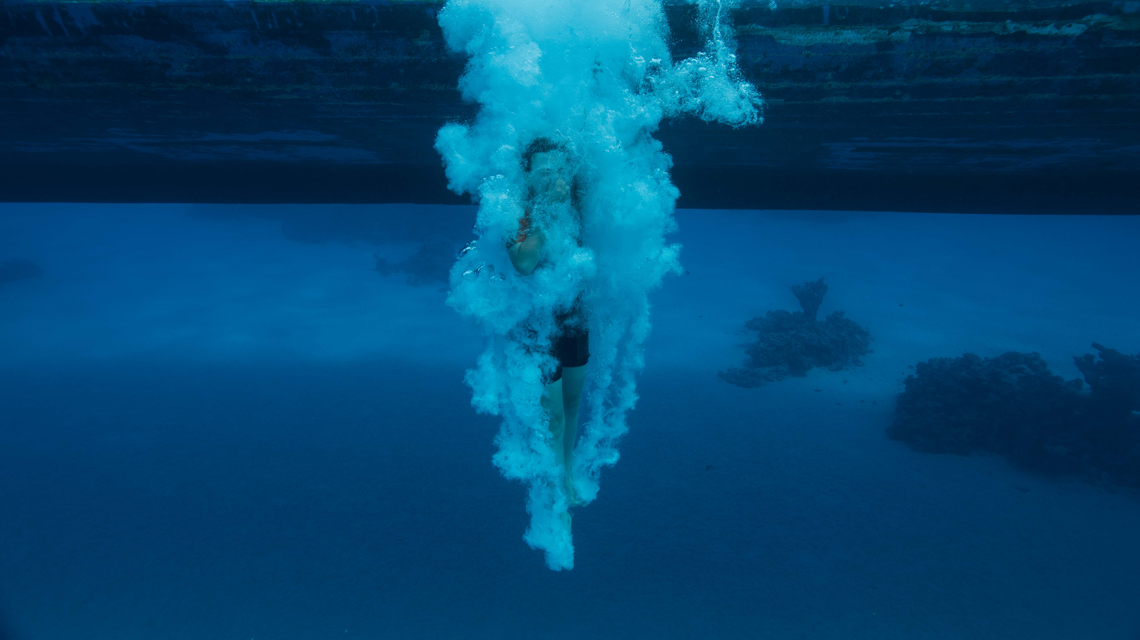

TRAVEL CONDITIONS
Cruise and Excursion Bookings
Please read our travel conditions carefully before making your reservation. Booking implies acceptance of these terms.
- Price
The prices are determined based on the season, the program, the price of flight tickets, and if applicable, the category of hotels/cruises. The balance must be paid in full 8 weeks before the departure date.
- Delays
The organizer is not responsible for delays occurring before departure or during the excursion or cruise if caused by technical issues, strikes, bad weather, or any other reason outside of our control. Delays due to weather or traffic may alter the excursion’s itinerary. Such alterations are not refundable.
- Unused Services During Your Trip
No refund will be granted for any unused services included in the trip. We reserve the right to change the boat at any time if circumstances require it, ensuring an alternative of the same category.
- Passports and Travel Documents
Passengers must ensure they have a valid travel document (passport or ID card) in order at the time of departure and valid for 6 months after the scheduled return date.
- Cruise or Excursion Responsibility
We will do our best to ensure that the cruise or excursion goes as planned. However, in some circumstances, we do not have direct control over services offered by suppliers and cannot guarantee the omission or errors made by said suppliers. We are also subject to weather conditions.
- Release Form
If you participate in one of our cruises, our dive master will provide all necessary safety instructions for snorkeling, freediving, and diving in the Red Sea at the beginning of the trip. After this briefing, you will be asked to sign a liability release form.
- Cancellation and Cancellation Fees
All cancellations must be notified in writing before the departure date. Cancellation fees will be applied based on a percentage of the total trip price: 60% if cancellation is made at least three weeks before departure, and 50% if cancellation is made more than a month before the departure date. No refund will be given for cancellations made less than three weeks before departure. Similarly, if your cancellation is due to a flight schedule change by the tour operator, no refund will be granted.
- Not Included in the Cruise Price
The price of the cruise or excursion does not include the entry visa and/or any other travel documents, phone calls, laundry service, or any other personal services not listed in the itinerary provided to you.
- Luggage
The reservation price includes one 20 kg luggage allowance if your reservation includes a flight ticket. The organizer is not responsible for loss or damage to luggage or any other personal belongings of passengers. We recommend taking out luggage insurance.
- Special Requests
Please specify any special requests when booking. We will do our best to accommodate them but cannot guarantee they will be granted. Please also mention if your health requires special or vital treatments and/or medications at the time of booking.

N'hésite pas si tu as besoin d'ajuster quelque chose dans cette traduction !

